**Standalone**

**Definition**

* A standalone application, also known as a desktop application, is a software program designed in such a way that to run this software program, users don’t need an internet connection or any server access.
* Web-based applications need an internet connection, servers, and any additional resources to run but standalone applications do not require any additional resources such as an internet connection, server, etc.

**Where Standalone will be used**

* A standalone application is used when a user wants to perform any specific task on a local machine, without the requirement of an internet connection to the system.
* Desktop software, Mobile apps, Gaming Applications, Industrial control systems Medical Devices, etc. are some examples where standalone applications are developed frequently.

**Features of standalone**

* **Offline functionality:** If the user uses standalone applications, then do not require an internet connection to run it, which makes them ideal for users who may not have a stable internet connection.
* **Better performance:** Standalone applications directly run on the user’s device without the need for an internet connection, and because of that standalone application provides faster performance and a better user experience.
* **Greater control:** Standalone applications do not depend on outside servers to store their data, so users have more control over their data when using the standalone applications.
* **Simple distribution:** These applications can easily make available to many users using the app store or any other platforms
* **Cost-effectiveness:** Standalone applications run on the local machines of users and do not require any server to store the data. So, these types of applications are less expensive and easy to design and operate.

**Difference between standalone and client server applications**

**Standalone**

* The standalone application is also known as a desktop application.
* To run the standalone application, a network or internet connection is not required.
* The standalone user’s applications can run on a single local machine.
* A single user can use Standalone Application tools and features
* Standalone applications may be preferred for their simplicity, ease of use, and offline functionality

**Client server**

* Client-Server application is also known as network applications, distributed applications
* To run the Client-Server application, a network or internet connection is required.
* The client-Server application can run on any machine which has an internet connection.
* Multiple users/clients can use Client-Server Applications.
* Efficient in scalability, flexibility, and ability to provide shared resources to multiple clients.

**Conclusion:**

* standalone applications are a type of software program that is designed to run on a single computer or local machine of the user, without the need for a server or internet connection.
* This application provides several benefits, such as offline capabilities and greater customization.

**Installation of standalone tool**

**Osquery:**

* Osquery is an open-source tool that allows you to query and monitor various aspects of your computer system using SQL-like queries.
* When used as a standalone tool, osquery provides a command-line interface (**osqueryi**) that allows users to interactively run queries against their system.

**How it Works in Standalone:**

* Osquery operates by querying system information using a SQL-like syntax.
* Users interact with osquery through the command-line interface (osqueryi).
* Queries are executed against virtual tables representing different system aspects such as processes, hardware, software, network connections, etc.
* Osquery retrieves system information in real-time and presents it in a structured format that is easy to query and analyze.

**Advantages:**

* **Unified Interface:** Osquery provides a unified interface for querying and monitoring various aspects of the system, regardless of the underlying operating system or environment.
* **Flexibility:** Users can write custom queries to retrieve specific system information tailored to their needs.
* **Real-time Monitoring:** Osquery provides real-time monitoring capabilities, allowing users to continuously monitor system activity and respond to events promptly.
* **Open-source:** Osquery is open-source software, which means it's freely available, and users can inspect, modify, and contribute to the codebase.

**Features**:

* **Query Language:** Osquery uses a SQL-like query language to retrieve system information.
* **Virtual Tables:** Osquery represents system information as virtual tables, making it easy to query and analyze.
* **Scheduled Queries:** Osquery allows users to schedule queries to run at predefined intervals and output the results to various destinations.
* **Extension Framework:** Osquery provides an extension framework for writing custom plugins to extend its capabilities.
* **Logging and Monitoring:** Osquery supports logging and monitoring functionality, allowing users to record query results, errors, and events.
* **Cross-platform Support:** Osquery supports multiple operating systems, including Linux, macOS, Windows, and FreeBSD.

**Conclusion:**

* osquery as a standalone tool provides a powerful and flexible solution for querying and monitoring system information, making it a valuable tool for system administrators, security professionals, and anyone else who needs to gain insights into their computer systems.

**Commands to install osquery standalone tool:**

* export OSQUERY_KEY=1484120AC4E9F8A1A577AEEE97A80C63C9D8B80B
* sudo apt-key adv --keyserver hkp://keyserver.ubuntu.com:80 --recv-keys $OSQUERY_KEY
* sudo add-apt-repository 'deb [arch=amd64] https://pkg.osquery.io/deb deb main'
* sudo apt-get update
* sudo apt-get install osquery

Give these commands in the root directory in terminal

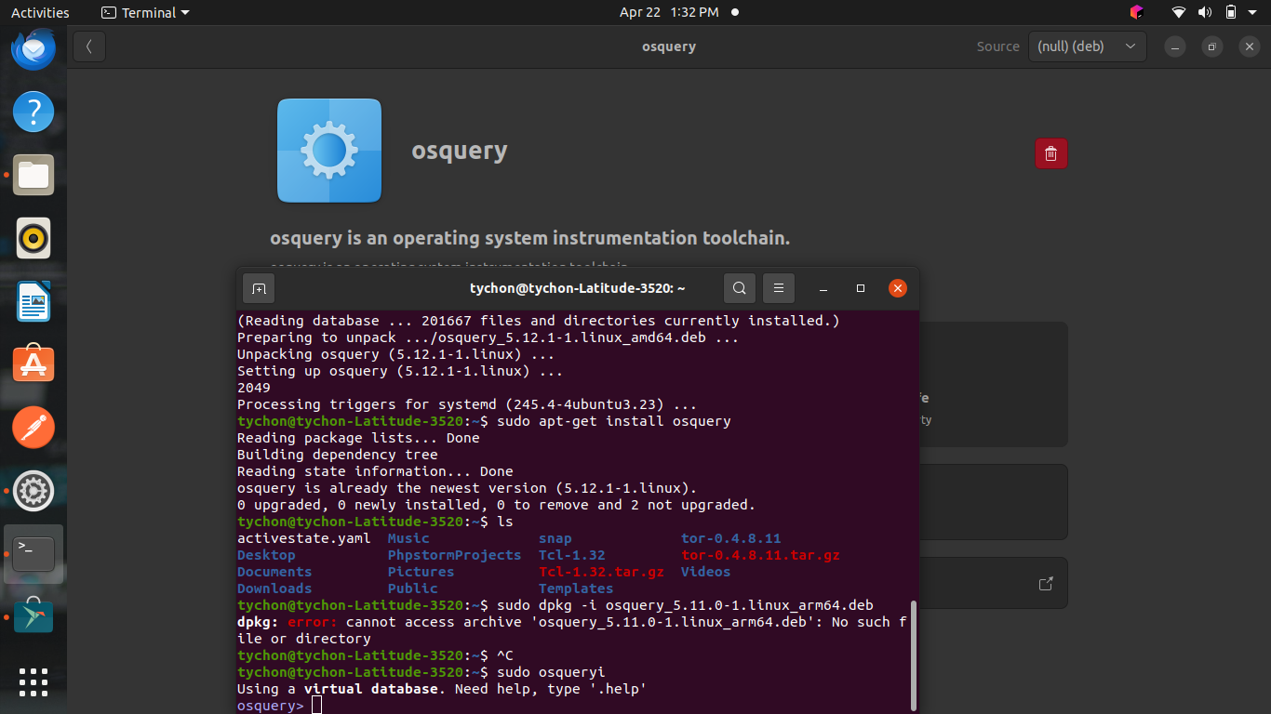

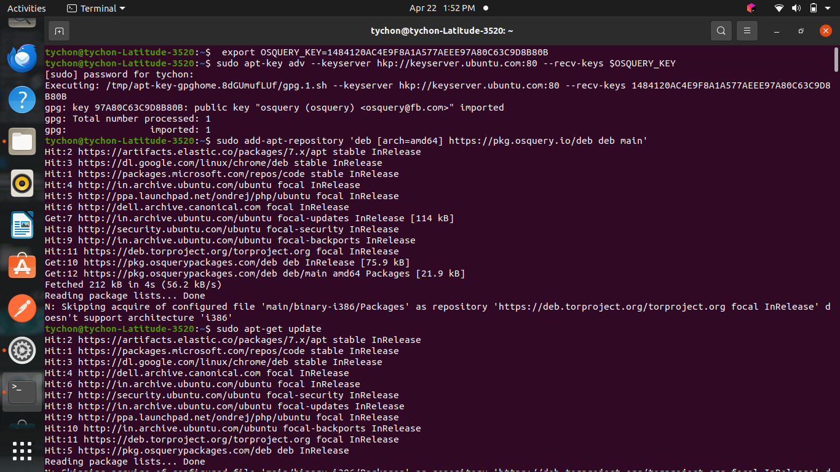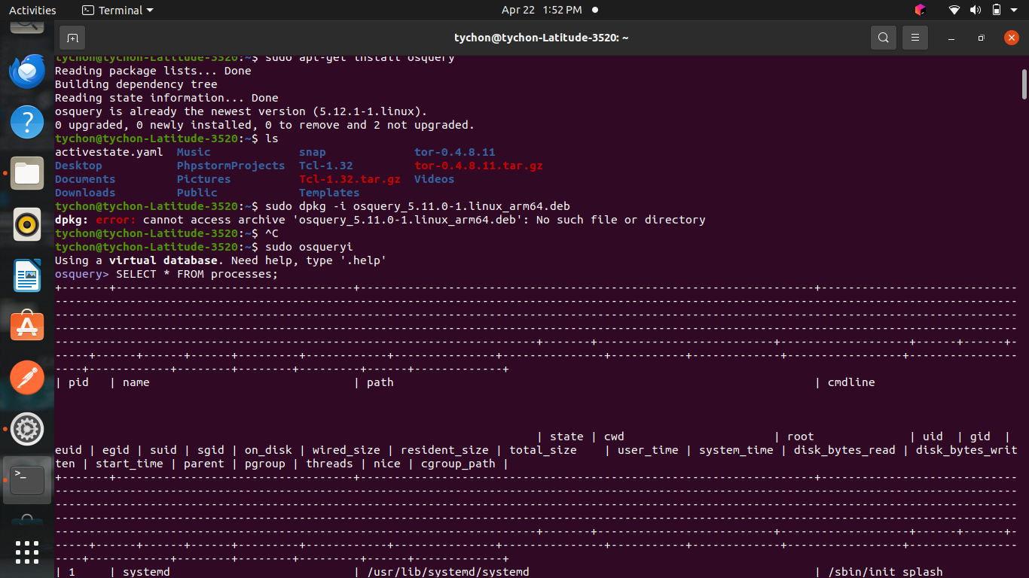

After this command give

sudo dpkg -i osquery_5.11.0-1.linux_arm64.deb

sudo osqueryi

SELECT * FROM uptime;

